

Job Description: Rainbow Support Worker
(Health Care Assistant)

Reporting to: Day Opportunities Manager

Location: Penley Rainbow Centre and / or Piercy Hall (Marchwiel)

Salary: £13.35 per hour, moving to £13.45 per hour effective from 1st May 2026

Hours: 21 hours per week (3 days)

Annual Leave: 33 days a year incl. bank holidays.

Employee benefits: Paid travel between sites
Holiday pay and pension scheme.
Full training and support given.
Supportive team environment where you can make a real difference and support community.
Contract: Permanent
Closing date: Monday 9th March 2026

To apply: submit your CV

Submit to: careers@rainbowfndn.org.uk
If you would like to discuss the role in more detail, please contact Eden Moseley at the Rainbow Foundation on 01948 830730.

About the Rainbow Foundation
Rainbow is an Ageing Well Centre of Excellence for Ageing Well, delivering award-winning, evidence-based support across Wrexham and North East Wales. We operate flagship Ageing Well and Dementia Hubs, provide mental health support in every GP surgery, run our multi-award-winning Active Futures programme, and offer outreach and community transport to reach older people who are isolated, rural, or underserved.
Our work is shaped by the belief that older people should live active, connected, fulfilling lives: valued, in control and with dignity. Our impact has been recognised nationally, with multiple Bevan Commission and King’s Fund awards, and strong partnership engagement across health, housing, local government and the third sector.
As we expand our hubs, strengthen community-based services, and influence policy on ageing well, Rainbow is entering a period of growth, fuelled by innovation and grounded in our six wellbeing principles.

Rainbow’s Strategy and Vision
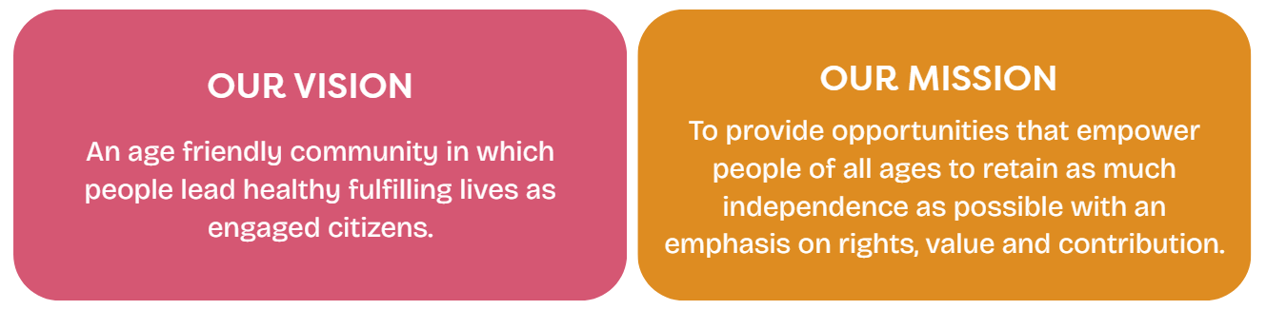
Our Values


If you are aligned to our mission and values now is an exciting time to join team Rainbow, in a role that will be both personally rewarding and make a real difference to the lives of those we support.
# inclusive culture # belong # create real impact # grow

Your role: job summary
To be an active member of a team and support in the day to day running of our busy Day Opportunities service promoting independence, facilitating social interaction and running quality activities. The Day Opportunities service provides a caring and supportive environment to older people, many of whom are living with frailty, dementia and other age-related conditions. Focused on active ageing the centres encourage physical activity and meaningful engagement.
Role Responsibilities:
- To assist in delivering a range of fun activities for our clients.
- Offer 1-1 support and care in line with care plans and risk assessments.
- To assist clients as needed, eating, toileting, mobilising, and getting into and out of transport. To assist with personal care needs as per individual care plans.
- To meet the personal care and support needs of clients in a way that respects dignity and promotes independence both in the centre and on outings.
- Complete basic daily records within client files and on our IT system
- To support with the transport of clients to and from the centres using our fleet of Rainbow vehicles.
- Support in making and serving drinks and snacks, serving lunch meals, and clearing up.
- Good understanding of the needs of older people and age-related conditions such as Dementia, frailty, and cognitive impairments.
- Good teamwork skills
- To actively participate in team meetings, supervision and undertake training as directed.
- Understanding of confidentiality
- Support with cleaning at the centre

An Enhanced Disclosure and Barring Service (DBS) check will be undertaken for this role.

PERSON SPECIFICATION

Post: Rainbow Support Worker

Key: A = evidence in your application I = evidence at interview

SKILLS ATTRIBUTES KNOWLEDGE AND EXPERIENCE
Essential | GCSE and above or equivalent in experience (A)  A caring individual who has the compassion, time and wants to support older people. (I)  Has an understanding of dignity in care, the importance of personal choice and issues relating to care work (I)  Has an enthusiastic and flexible approach to working. (I)  Ability to use own initiative yet to work well as part of a team. (I)  Ability to maintain confidentiality. (I)  Physically able to perform all aspects of the job role. (A+I)  Willingness to join in with hobby areas which can be shared with older people and people living with dementia e.g., crafts, singing, baking. (I)  Demonstrates values in keeping with The Rainbow Foundation in relation to the support of older people in our communities (I)  Effective record keeping (A+I)  Flexible and responsive in your approach to work. (A+I)  Able/Willing to support personal care. (A+I)  ,
Desirable | Previous experience in a caring role, paid or unpaid desirable. (A)  Qualification in relevant subject such as Health and Social Care (A)  Able to drive and have business insurance. (A)  Basic skills in ICT (A)  Experience of delivering personal care (A)  Willing to go out on trips with the individuals attending the day opportunities service (I)
Others | Must be willing to have an enhanced DBS check (A)

The Rainbow Foundation is an accredited Real Living Wage employer, we have an Employment Assistance Programme in place to support our staff’s wellbeing and are an Equal Opportunity employer.


